Game Design Document

Fill up the following document

1. Write the title of your project.

*My title of the game is VISION CARE.

1. What is the goal of the game?

*to allow the user to check the color vision and to Strengthening of ocular muscles (eye muscles).

1. Write a brief story of your game.

*The screen timming on laptops,Mobiles are increasing due to that people are not getting(giving) proper rexalsation to their eyes .So, from the following app to user can check their eyesights and can also practice the ocular exercises .

1. Which are the playing characters of this game?

* Playing characters are the ones who respond to the user based on the input from the user.
* Cars, monkeys, dinos, wizards, etc., are the playing characters in the game.

|  |  |  |
| --- | --- | --- |
| Number | Character Name | What can this character do? |
| 1 | user | Practice the eye exercise  And to check eye colour vision |
| 2 |  |  |
| 3 |  |  |
| 4 |  |  |
| 5 |  |  |
| 6 |  |  |
| 7 |  |  |
| 8 |  |  |

1. Which are the Non-Playing Characters of this game?

* Non-Playing characters are the ones that don't have an action or behavior when the user interacts with the game.
* Hurdles, stones, bananas, coins, etc., are non-playing characters in the game.

|  |  |  |
| --- | --- | --- |
| Number | Character Name | What can this character do? |
| 1 | Pendulum | Makes horizontal movement of eyes |
| 2 | illusion | To make eyes and brain concentration strong |
| 3 | Ball moving | Make the movement of eyes at 360° |
| 4 | Colour charts | Checks users colour vision |
| 5 |  |  |
| 6 |  |  |
| 7 |  |  |
| 8 |  |  |

Draw your imagination of this game. What does this game look like?

* Draw the game either on your computer or on paper
* characters at least once. 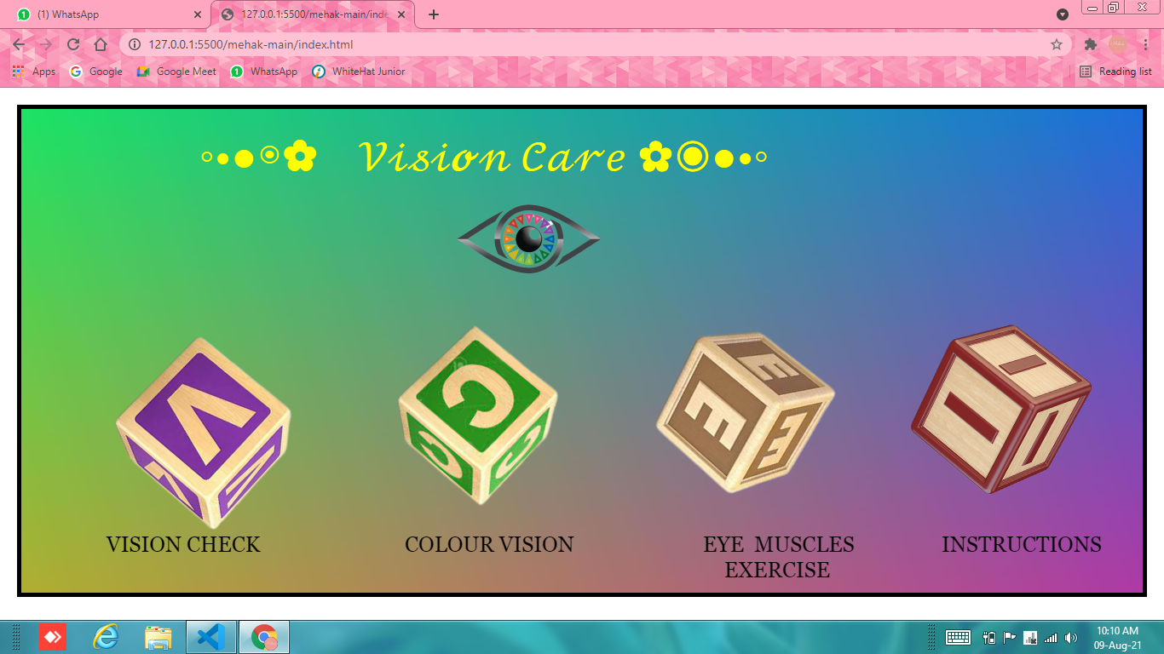

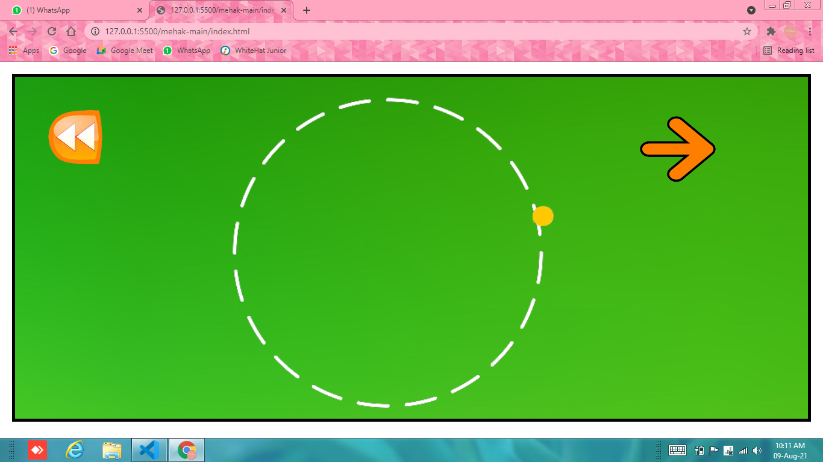

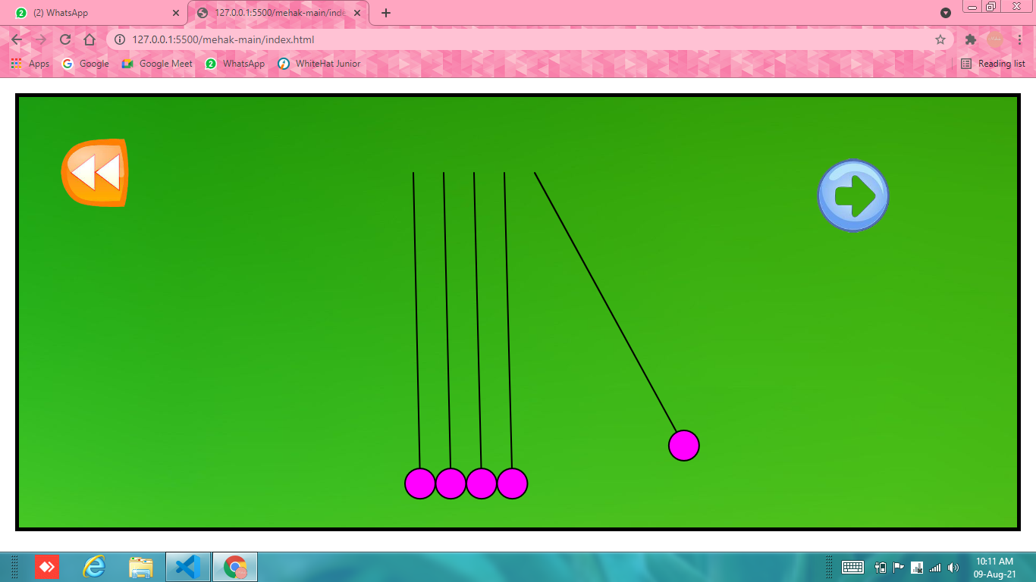

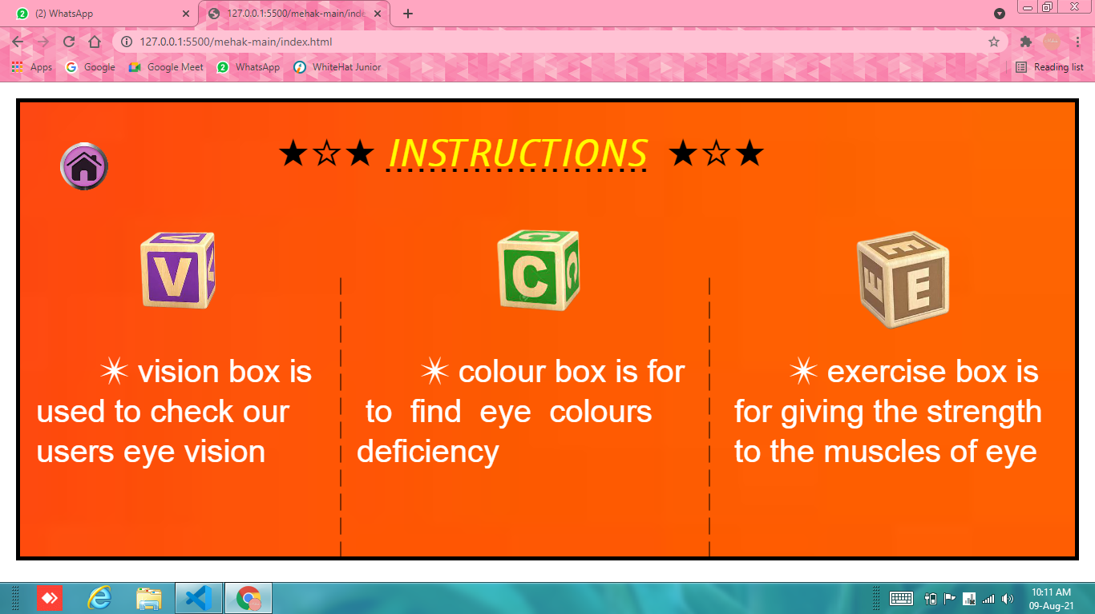

How do you plan to make your game engaging?

By including more in exercises and by using more advance features of coding to check eyesight.